

**AccessABZ**

**Thursday 4th October 2018**

**Attendees**

Fraser Bain (FB), AIA

Kevin Douglas, AIA

Stan Flett, Scottish Accessible Transport Alliance

Prof. Julian Malins, Disability Equity Partnership

Sarah Geoghegan, Alzheimer Scotland

Sam Reid, Deaf Action

Judith Forbes, NHS Grampian

Katrina Michie, Shopmobility

Joan Allan, G4S

Graeme Coutts, G4S

**Special Guests**

Claire McDonald, Sport Aberdeen

Lewis Clow, Sport Aberdeen.

**Apologies**

Shona Owen, Service User

Andy Hyde, Upstream Scotland

Pamela Munro, Guide Dogs for the Blind

Andrea Barclay, Service User.

**Notes from Meeting**

**Introductions**

This is the first forum meeting attended by Professor Julian Malins representing Aberdeen City Council’s Disability Equity Partnership. The purpose of the partnership is to bring about improvements to the lives of people in Aberdeen who experience exclusion because of their disability, by promoting a rights based approach to disability equality. Similarly, this is the first forum meeting attended by Sarah Geoghegan, a Dementia Advisor from Alzheimer’s Scotland. The airport has previously hosted an airport tour with Sarah and the Positive Dementia Group from Aberdeen gaining feedback about the facilities and giving members the confidence to fly. Alzheimer Scotland have also provided Dementia Friends training to members of our team.

Two special guests, Claire McDonald and Lewis Clow from Sport Aberdeen were invited to the forum to provide an alternative perspective on accessibility and to share their experiences. Claire is a development officer for Sports Aberdeen and has worked with a range of athletes with a disability. Lewis who now works full time in IT at Sport Aberdeen is an athlete with Cerebral Palsy and he competed at the 2014 Commonwealth Games (100m sprint T37).

He had just returned from Spain after competing at the Cerebral Palsy World Games. Lewis gave a fascinating account of how he got into running and really interesting background on the trials and tribulations he endured on the way to competing in Glasgow in 2014. Lewis travels quite a bit personally and through sport and often through ABZ so he was able to give a great insight into his experiences and challenges in passing through an airport. His girlfriend Megan is a wheelchair user and also an athlete so Lewis was able to share some of her experiences as well. Lewis’s talk prompted several questions from the forum members and an enjoyable discussion. We were all very grateful for the time given up by Claire and Lewis to attend the forum during their lunch break and providing such an interesting presentation.

**Airport Operational Update**

FB explained that 1,827,000 passengers had flown through the airport YTD (Up to and including August) in 2018. Although this represented a 0.5% increase on 2017 there has been a downward trend over the last few months caused by the cancellations of the Frankfurt and Warsaw services in the main.

The total number of Passengers with Reduced Mobility (PRM’s) YTD (Up to and including September) is 17,062, a 2% rise on 2017 figures.

As stated previously the consistent rise in the number of PRM’s partly reflects the increased awareness of the services and facilities that airports can provide in terms of assistance and the growing levels of confidence in the assistance available.

The following table provides a breakdown of the different types of assistance requested in Aberdeen in 2018;

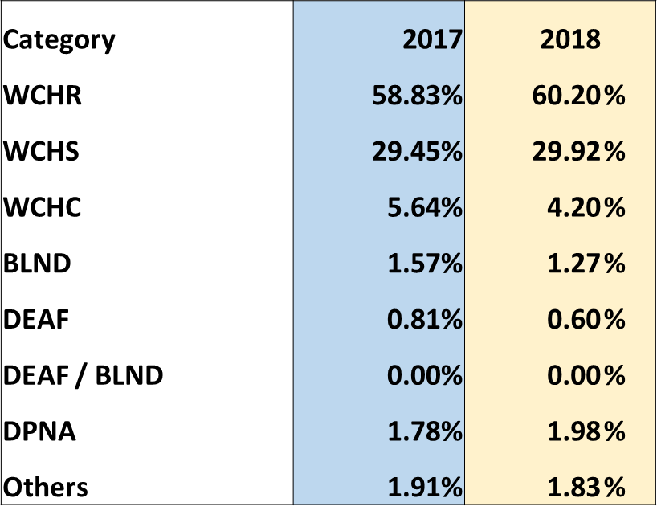

Approximately 60% of requests were for wheelchair assistance through the airport to/from the bottom of the aircraft steps (WCHR)

Combining the WCHS and WCHC totals represents passengers in wheelchairs who required the use of the Ambulift vehicle to get on or off the airplane (approximately 35% of all requests). Passengers that are classed as WCHS are able to make their own way to/from their seat in the aircraft and WCHC classed passengers require to be lifted into their seat.

DPNA is the classification of disabled passengers with intellectual or developmental needs that require assistance. Although, this group only equates to around 2% of all assistance requests in 2018, this is a group that is growing in number. It is also worth highlighting that an unknown number of passengers who would fall into this classification opt to wear a hidden disability lanyard through the airport and travel independently, not requiring the formal assistance service.

**Pre-notification**

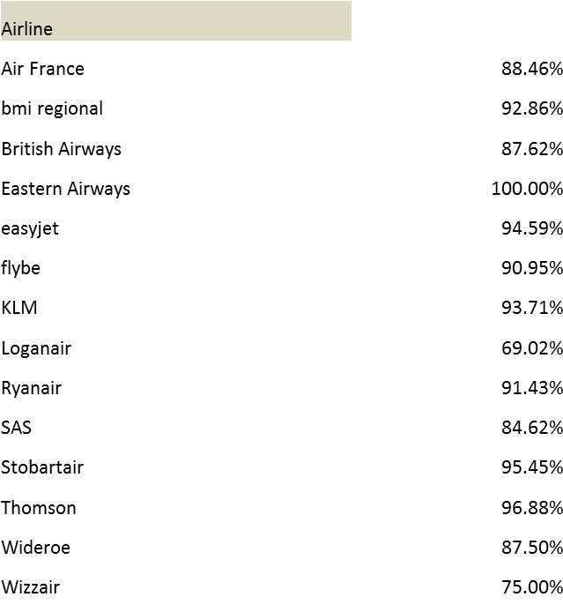

The average pre-notification rates currently sits at 89%. By airline this ranges from Loganair at 69% to Eastern Airways at 100%.

The point was stressed that a large number of hospital patients travel with Loganair to/from the Northern Isles as they visit Aberdeen Royal Infirmary. The nature of this travel does mean there are several occasions when the standard 48 hours pre-notification cannot be met. G4S highlighted in fact, that they have seen a great improvement in advanced notification for hospital patients and thanks is due to Judith Forbes and the booking team in the NHS for these results.

**PRM Complaints/Compliments in 2018**



14 complaints received YTD against an overall figure of 21 in 2017. 9 compliments received YTD against an overall figure of 6 in 2017.

**Summary of Complaints**

* 3 complaints regarding assistance equipment. Wheelchairs and Aisle Chair
* 3 complaints regarding staff attitude and behaviour at Assistance desk
* 4 complaints regarding delays in providing assistance service. Ambulift in use at another aircraft and boarding of assistance passengers after all other passengers.
* 1 complaint from a passenger who missed his flight. (late to arrive at the airport)
* 1 complaint from a passenger who was not asked where they wished to wait.
* 1 complaint from a member of the public about not engaging with PAMIS (Promoting A More Inclusive Society) regarding our new Changing Places facility.

**Commentary regarding Complaints**

We replaced our entire set of wheelchairs in May of this year and have ordered a new aisle chair. We are expecting delivery of a new Ambulift in December.

*Julian Malins wanted to raise the matter of the Ambulift being in a dirty condition on behalf of Dame Anne Begg. Kevin Douglas is following up on this with our cleaning team and organising a deep clean to take place.*

The complaints regarding the staff attitude focused on one particular staff member. This member of staff was provided with refresher training on customer service. One of the observations was made by a member of the public who had a different set of expectations on the role of the assistance provider.

The assistance team during peak periods face a challenging job to ensure that every passenger is met on time. It is inevitable that passengers will start to feel anxious if they are not being assisted when they expect it (despite reassurances from the team). On 4 occasions passengers have followed up with a complaint about delays. Unfortunately, the ambulift vehicle can only service one aircraft at a time and there will be odd occasions when there will be a short delay in providing assistance.

*The group were informed that two of the handling agents will shortly be using Aviramps including Dalcross on the Loganair flights that service Orkney and Shetland and have a high percentage of assistance passengers. Picture below of the type of ramp which can be used by all passengers.*

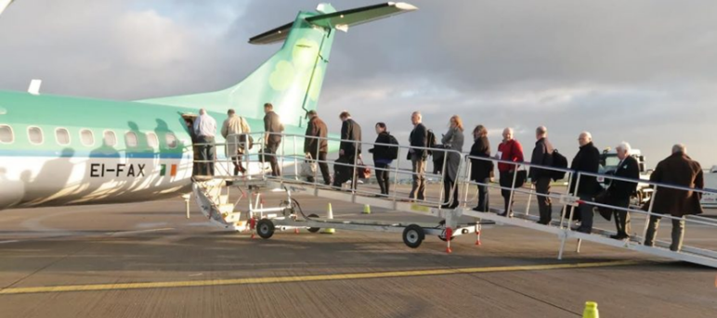

On one occasion a passenger who received assistance missed his flight. Although G4S did take some learnings from this incident, ultimately, it came about because the passenger arrived late at the airport (35 minutes prior to his flight). The passenger was also held up at Security for a short period as he had some non-compliant liquids in his hand luggage.

G4S have also reminded their agents that clear communication is very important and that they should make sure that any passengers they are assisting understands what is happening. This action was taken following a complaint from a passenger who said he was not asked where he wanted to wait in the departure lounge.

Lastly, a member of the public got in touch to complain that we should be engaging with PAMIS when planning our Changing Places facility. We were happy to report to the person that we were in fact in discussions with PAMIS.

**Compliments**

We have received 9 formal compliments about the assistance service this year YTD against 6 from 2017 in total. It is pleasing that we have received more compliments this year and it has to be noted that we continue to receive a lot more informal verbal compliments for the hard work carried out by the team.

**Accessibility/Assistance Updates**

**Lanyards**

The hidden disability lanyards that can be requested by passengers continue to be very popular and we have had to place 2 more orders this year to replenish our stocks.

At previous forums members have suggested introducing alternative, less ‘obvious’ means of highlighting a hidden disability such as a pin or bracelet. At the last forum a discussion took place that a pin might be quite difficult to be seen and a metal object may cause a potential issue at Security. However, in response we have introduced a card that can either be attached to the bottom of the lanyard or carried separately and presented to a member of staff to explain what help may be required. The card has space on the back for the passenger/carer to write down specifically what they find difficult or what assistance may be needed. A picture of the cards are below;

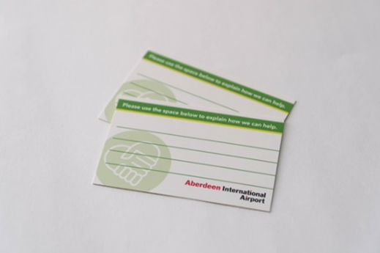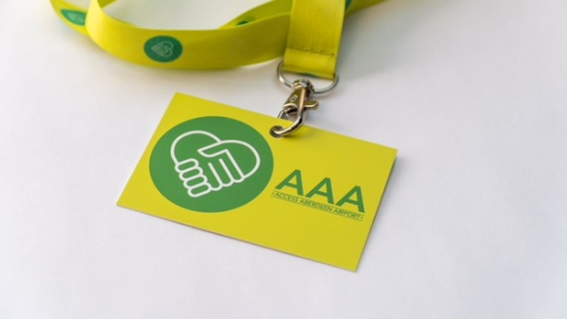

AAA stands for Access Aberdeen Airport.

It appears that we may be slowly moving towards standardising the type of lanyard provided at UK airports. The CAA are encouraging airports to work together to achieve a positive outcome. The sunflower lanyard appears to be the most commonly used and we are, along with our sister airports, Glasgow and Southampton, looking into this further. We have always stated that it would be easier for the passenger if there was one type of lanyard in use.

**Disability Awareness training**

Hidden Disability training along with diversity and equality training is now a standard part of Security Officer’s training.

Alzheimer Scotland provided further Dementia Friends training for some of our team in May and we are organising basic sign language training for our team customised for the airport environment.

Although we don’t have a confirmed date we will be reaching out again to North East Sensory Services to provide further sensory awareness training included sighted guiding.

In 2019 we will be looking to organise similar awareness/training for our teams.

**Community Engagement**

With the aim of increasing awareness among the community about the assistance services and facilities we have at the airport we will be approaching local organisations in the coming months to arrange sessions at their locations. Earlier in the year we attended a Rainbow Rogues meeting near Ellon. The group provides family support for children aged 0-5 with a disability or additional support needs. We received really positive feedback and the parents found the session useful and informative.

**Facilities for Northern Isle passengers**

Several meetings have taken place with Loganair among other organisations with the aim of providing a more suitable waiting area airside. Discussions are on-going and we are committed to delivering a facility that is welcomed by all.

**Assistance area landside**

We are currently working on plans to relocate the assistance area at the front of the terminal so it is more visible. The Eastern Airways desk is no longer in use and the Swissport desk will be relocated to where the assistance area is currently which will leave this area free to locate the assistance area. It is envisaged that this work will be completed in the first quarter of 2019 and during this time a temporary assistance area will be in use.

**PRM video update**

We carried out filming in July and were grateful for the time and effort made by our volunteer actors. We are just in the process of editing the footage but aim to have the videos complete by the end of the year.

**Harley, our therapy dog!**

We have had a really positive response following the appearance of our therapy dog Harley in the terminal on several occasions this year. We have managed to arrange a couple of the visits around passenger requests. (Nervous flyers, autistic children) The BBC have also filmed Harley in action for two separate programmes.

**Changing Places toilet**

In the last week we have opened our Changing Places toilet airside (part of a new toilet facility in the departure lounge).

**Andrea Barclay now a member of Airport Consultative Committee.**

Andrea, an Access Forum member most recently attended a committee meeting at the beginning of September; chaired by our Chief Executive and she raised some important accessibility issues.

**Orkney and Shetland Hospital Patient Transfer working group set up.**

NHS, Loganair, Handling Agent, G4Salong with the airport meet to discuss the specific needs and expectations of patients travelling from the Northern Isles to Aberdeen.

**Change of hospital patient transport provider for the NHS**

The service, previously run by the Red Cross is now provided by Falcon Coaches.

**New handling agent for Loganair**

Dalcross have replaced Menzies as the handling agent for Loganair

**G4S Star of the Month award**

PRM Agents won the G4S Star of the Month award in June, an internal award judged by Regional Management

**Feedback provided by Andrea Barclay and Pamela Munro during filming for PRM video**

**Assistance Telephones – Suggestion for a phone to be located by the bus shelter.**

*We have assistance telephones situated in the drop off area and car parks but do not currently have one in the lower forecourt where the Jet 727 and Long Stay car park buses drop off passengers. There is a phone to call the Long Stay bus and we are looking at the feasibility of being able to call for assistance from the same phone*.

**Staff Training – Sighted guiding and general awareness training required.**

*As per the update provided previously it is our intention to provide regular training for our own team and third parties. We are approaching NESS to provide sensory awareness training.*

**Assistance Desk – location and height.**

*This observation was possibly made as during filming we approached the desk from the direction of the main entrance. (highest point of desk) The desk actually has a lower section but due to the location of the desk this is not easily seen. It is thought that the relocation of the assistance area will mean that passengers will approach the desk directly and will be able to access the lower section without any difficulty.*

**Collection of Luggage – lack of seats halfway down the corridor and no designated assistance seating. Seating also considered to be too low for some passengers.**

*We have now added in more seats along the length of the corridor to address this issue. There are currently more seats in this area than there will be in the future but we will ensure they are still located in the middle section as well as at the start and near the reclaim belt. We are looking to invest in some raised seating as this has been raised previously.*

**As raised at last forum meeting suggestion for assistance baggage to be given a specific bag tag.**

*This is something that we will speak to the CAA (as regulators of the assistance service) about to understand how this might be pursued.*

**Suggestion for Volunteers to be utilised at the airport to assist.**

*We are reviewing the business case for having a team of volunteers at the airport who could provide a customer service role.*

**Suggestion to install Welcome app**

*The Welcome App by Neatebox is a form of booking system that allows the passenger to specify the assistance they require and acts as a reminder for staff as to how to help the person in front of them. The technology also means that the assistance provider is alerted to when the person arrives and provides a photo of them. The app is free to use for the passenger but a significant investment is required from the business to use it. Although we have not ruled out the use of the app we still need to be convinced that there is sufficient demand and that the system provides significant benefits.*

**CAA Airport Accessibility Report 2017-18**

We did not have time to discuss the CAA Airport Accessibility report for 2017/18 in which Aberdeen were rated, along with 15 other airports as ‘very good’.

**Summary of report**

* Over 3 million requests were made for assistance at UK airports in 2017 and requests for assistance are increasing at a rate of around double that of general passenger growth.
* 83% of passengers satisfied with assistance service in UK (54% - very satisfied)
* However, satisfaction levels of passengers with reduced mobility are marginally lower than those of general passengers.
* 16 airports classified as ‘Very Good’, up from 6 last year. 10 airports are graded as ‘Good’, 3 airports ‘Need Improvement’ and one airport was ranked as ‘Poor’.
* CAA are looking for airports to have a particular focus on data collection to ensure that accurate information is available about the service and how well it meets the needs of passengers
* Imperative costs are not cut by airports in terms of the assistance provided to passengers. Good assistance depends on staff availability, quality of their training and customer service skills and availability of specialist equipment.
* Aberdeen was ranked as ‘very good’ in the report.
* The common theme among airports classified as very good is that, against a backdrop of increasing numbers of people using assistance services, the staff at each of these airports have worked hard to ensure standards are maintained; that waiting times are kept to a minimum, users of the assistance service are treated with dignity, care and attention.

**Terminal Transformation Update**

We did not have time to talk about the progress on the Terminal Transformation. Instead the airport will host an airport tour in November which will include the new Security search area and Changing Places toilet. An invite will be sent out.

**Feedback from Access Forum Members**

* Issue that external steps do not have edging strips and question over whether tactile paving was in place.

*Work will be carried out on this area to provide required edging and tactile paving.*

* Lack of Flight Information Screens in Departure lounge and Security area that are at eye level.

*We plan to review the options as we need to identify the best area for these screens and the work required.*

* Lack of signage at strategic points – confusing for passengers.

*This will be picked up on a ‘passenger journey’ tour of the airport which we plan to hold in 2019.*

* Late notification of gates can make passengers anxious and worried that they are waiting in the right place. Julian wondered if it is possible to text the gate number to passengers or have some sort of audio read out of flight information from boarding card.

*We need to understand if technically possible at this time with our flight information system (Chroma) or what options we may have going forward. We will be introducing a new version of this system in 2019 and this could present some alternative options which were not previously available.*

* Taxi waiting area – Julian. Should be a lounge for waiting passengers.

*Advised that there are 2 taxi products – pre-booked with the waiting area and walk up rank. Julian unaware of pre-book option.*

* Option to do further work / tours with Positive Dementia group?

*FB advised he plans to visit group and deliver talks on airport etc.*

* Are ticket /pay machines in Car Park at a lower level for wheelchair users?

*We have asked our car park operator, APCOA to advise.*

* Are cash machines (ATMs) at a lower height?

*Travelex asked to advise.*

The next Access Forum meeting will be held in March 2019 – date to be confirmed.