Departing from Aberdeen International Airport

Welcome to Aberdeen!

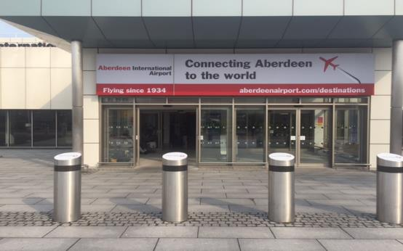

- Getting to (arriving at) the Airport

You can arrive at the airport by Car, Bus or Taxi. The bus or taxi will drop you off near the front of the Terminal Building. The Short Stay car park is located within 100 metres of the front door. A bus will drop you off at the terminal from the Long Stay car park.

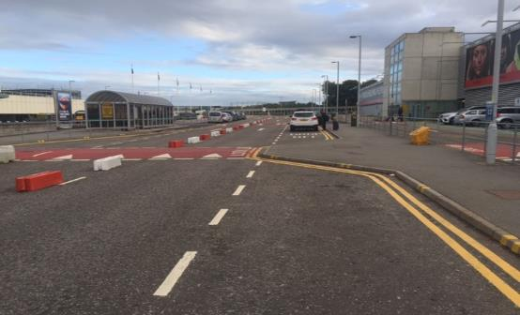
Drop off area near the front of the terminal.

If you have arranged for assistance you can use the assistance telephones located in the drop off area or glass vestibule in the car park to speak to our assistance team.

Drop Off area help point and waiting area.

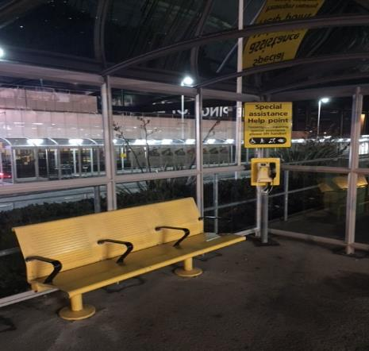
Phone will automatically ring through to the Assistance team

Short Stay car park help point and waiting area

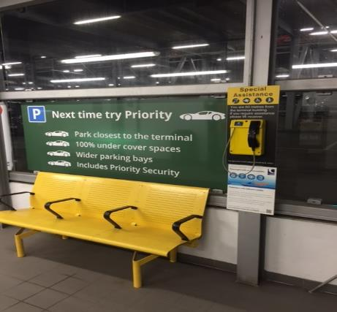
Phone will automatically ring through to the Assistance Team

Trolleys are available if you are travelling with luggage from various trolley bays situated in the drop off area and car park.

There are two entrances (automatic doors) to the Terminal Building. The main entrance is straight ahead of you when you walk from the drop off area and takes you in to the check in area. There are also doors in to the terminal on the right hand side – this is a quieter entrance if this will help.

Main entrance to Terminal

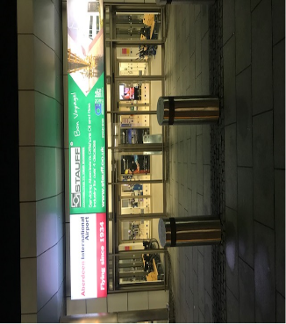

Alternative (quieter entrance)
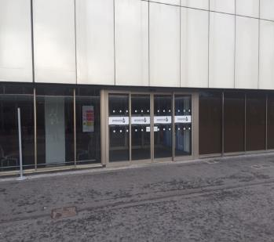
Automatic Doors

- Checking In

If you have already checked in for your flight at home, have your boarding pass and don’t have any baggage to check in you will be able to head straight to Departures. (See Departures section)

If you need to check in and/or have baggage to check in, you should check the Flight Information Screens to find out the check in desk for your flight. The screens are situated straight ahead if you have entered the terminal by the main entrance.

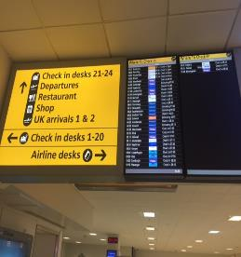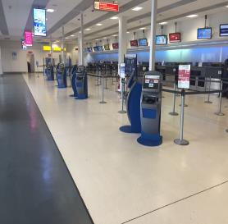
Flight Information Screens
Check In

If you have any questions or concerns about checking in please ask any staff member. We have an Airport Ambassador who will be happy to help.

If you are checking in at a desk, you may have to wait in line to be served. Please be aware the check in area can get busy.

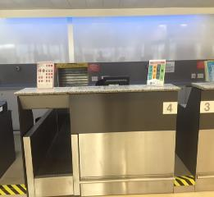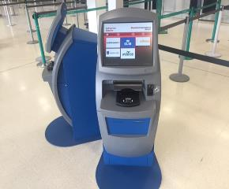
Self -service check in machine
Check in Desk

You may be able to check in at the Self Service machines depending on the airline you are flying with. Please check the machine for details or ask a member of staff for assistance.

You will be able to print your boarding passes and in some cases your Baggage Tags at the self-service machines. If you have baggage to drop off you should now go to the relevant check in desk.

At the check in desk you will be asked for your identification (e.g. passport or driving licence) and your booking details in order to give you a boarding pass for the flight (if you don’t have this yet). You will be asked to put your bag on the scales. Once a bag tag has been attached, your bag will be taken to be loaded on to the aircraft.

- Assistance area prior to Security

If you have requested assistance for your journey through the airport and on to the plane you will be directed to the Assistance Area which is located opposite the main entrance of the terminal. You can pick up a hidden disability lanyard from this desk if you require one.

A member of the assistance team will meet you here to take you through Security Search. If there is no one at the desk on arrival and you have any questions or concerns you can speak to the assistance team using the phone on the desk. Water is also available while you wait.

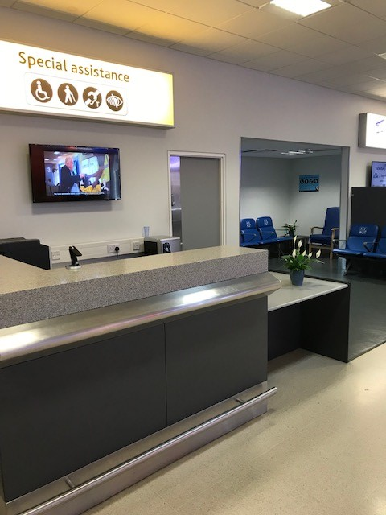
A member of the assistance team will be on hand to assist

The closest toilets are located opposite the Assistance area beside the Granite City bar and kitchen. Accessible toilets are available opposite Check in desk 24 prior to Security.

Accessible Toilet
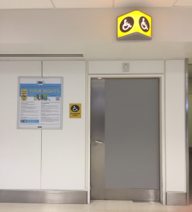

- Airport Security

Before entering Security you should make sure you have your boarding pass ready and you have a clear plastic bag for any liquids. You can get these bags at the entrance to Security.

Liquids must be less than 100ml and there are bins located before security to dispose of items that are not allowed.

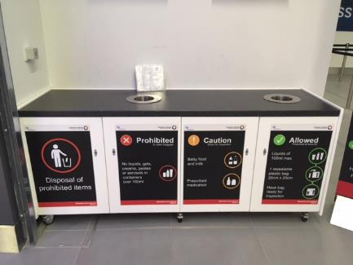
Bags for liquids
Boarding Card check.
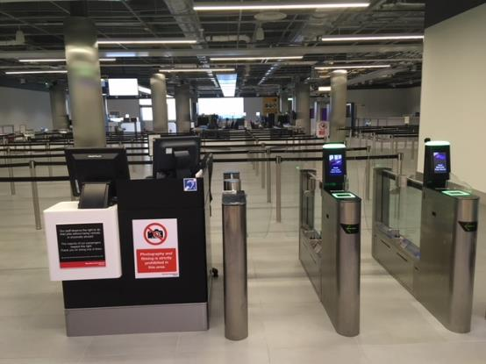
Automatic boarding pass gates
A security officer sits here and can assist

Security can be a busy area and there may be queues of people waiting to get through. A priority security lane is available on the left hand approach for those passengers who are entitled to use it. Passengers who require assistance are entitled to use this lane.

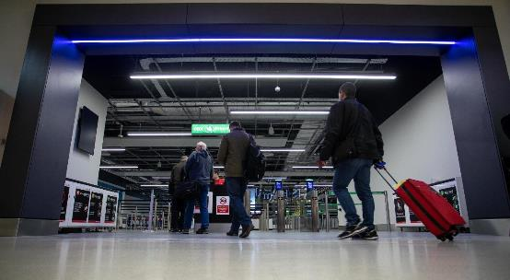
Priority passengers go this way

The automatic gates will open when you scan your boarding pass. Please ask the member of security staff situated in this area if you require any assistance.

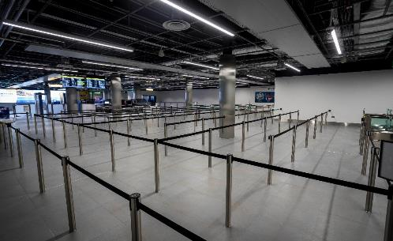
Queuing area at Security

As you approach the security search area please take a tray from underneath and place any hats, scarves, jackets, boots, belts, watches, wallets, keys, liquids and electronic items in here. The liquids should be in a separate plastic bag and placed in the tray. Any laptop or iPad should be placed in a separate tray.

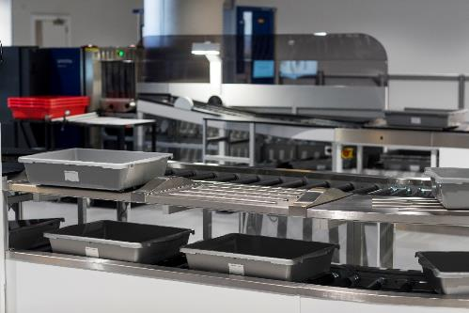
Loading area – take a tray from underneath

The Security Officers in the search area are there to assist and may ask you if you have put everything that you should in the tray provided. You will be able to push the tray on to the rollers when there is a gap to do so. The tray will then be put through the x ray machine and you will be able to collect this after you pass through the scanning equipment.

You may have to stand in a short queue at this point before a security staff member asks you to walk through the archway metal detector.

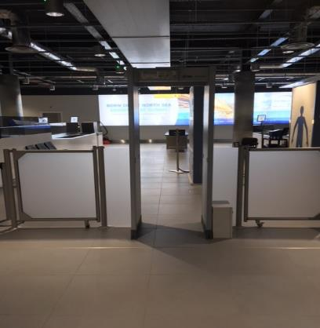
Archway metal detector

The archway metal detector may make a noise as you pass through it which will mean that you will be subject to a further search in our body scanner. Don’t worry, this is perfectly safe and happens many times each day. If you have any concerns or questions, please ask a member of the Security team (they all wear the same uniform and are easy to identify)

Depending on whether the body scanner alarmed the Security Officer may ask you to step inside the body scanner

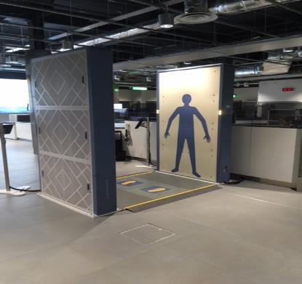
Body Scanner

Place your feet over the feet marked on the floor and stand with your arms to the side like the silhouette that is facing you. The scan will only take a few seconds. The Security officer will inform you if he is required to give you a physical search. You may ask for a private search (accompanied by a family member/carer) if this is more appropriate.

Once you have completed the search process you will be able to collect your belongings from the trays at the end of the rollers.

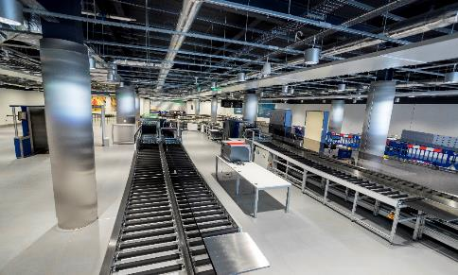
Trays will come down these rollers

Please take your time to redress and pack your things away safely in the re-packing area.

The route to the departure lounge is through the World Duty Free store. If you have any sensory issues which makes it difficult to pass through such an environment please advise one of our Security Team and they will open a door for you that bypasses this area.

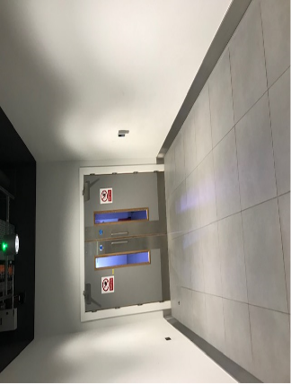

- Departure Lounge

You are now in the Departures area. When you leave the Security Search area you will pass through World Duty Free and other retail areas.

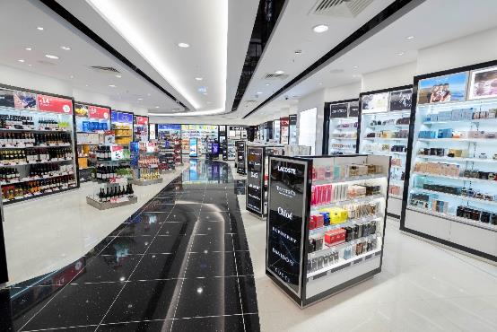
Shopping Time!

WH Smith bookstore
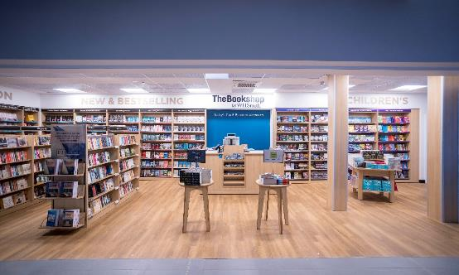

WH Smith

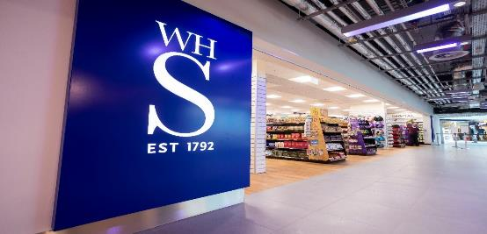

There is also a Boots store, Costa Coffee and two bars/restaurants called the Distilling House and Bocco in the departure lounge.

The Northern Lights and British Airways Lounges are situated close to Gate 1. It can be accessed by a set of stairs or a lift.

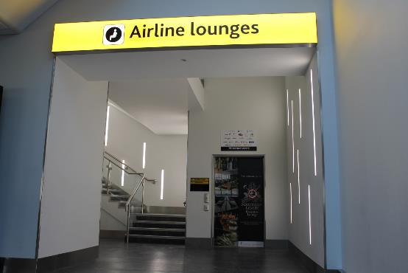
Lift

You should take time to check the flight information screens situated throughout the departure lounge for an update regarding your flight including the number of the departure gate.

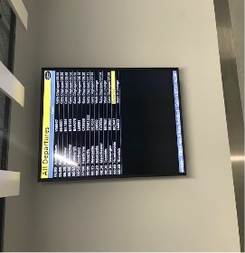

Changing Places Toilet

We have a Changing Places toilet located beside the Distilling House bar/restaurant on the upper departure lounge. You do not require a key to use this facility.

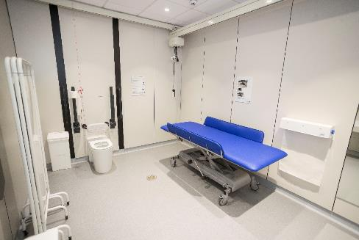
Seating in Upper Lounge

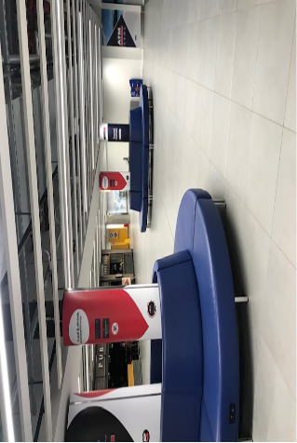

There is a lift in the atrium area to take you down to the lower departure lounge. Hold the button down until the lift reaches your level. Once inside the lift hold down the ‘G’ button for Ground until the lift reaches the ground level. (Alternatively hold down the ‘1’ button until you reach the upper level)

Departure Lounge Lift (view from upper lounge and lower lounge)

Accessible Lift
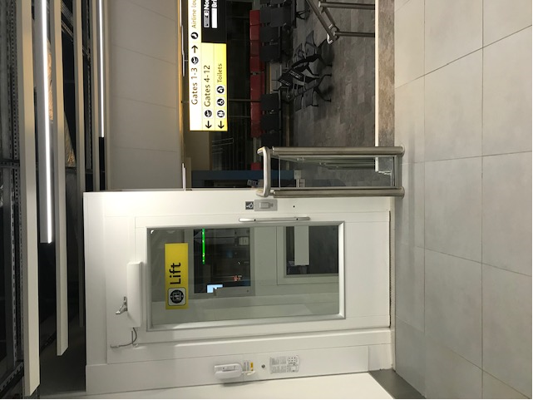

Departures Gates 1, 2 and 3 are situated on the right hand side after exiting the lift or coming down the stairs. Departure Gates 4-12 are located on the left. The departure lounge can get busy at peak times.

.
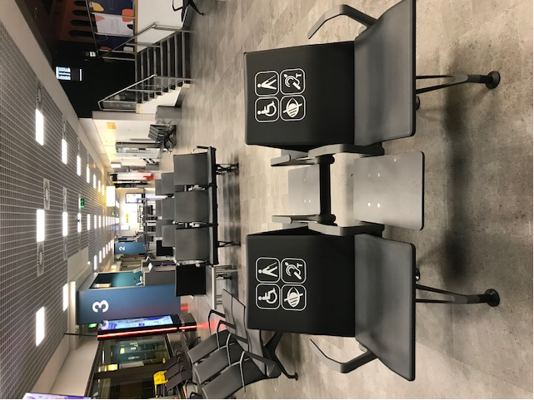

Gates 1 and 2

International flights are normally boarded through Gates 1 and 2.

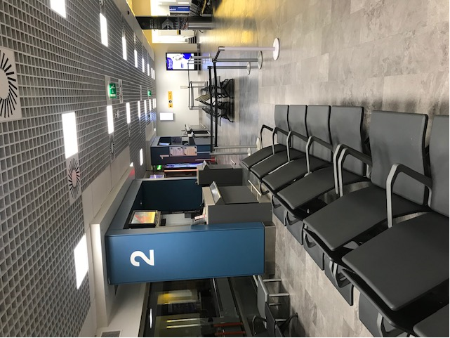
International Flights board through Gates 1 and 2

Gates 6 – 12 and the Eastern Airways Lounge are situated on the Northern Walkway. Past Gate 5 follow the ramp up to the top and turn right.
Gates 6-12 are located away from the main facilities

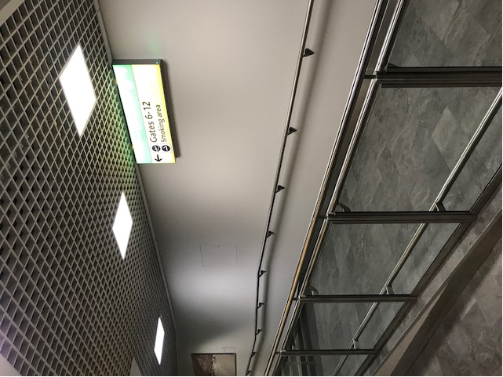

You can use either the stairs or the lift which is marked on the picture below

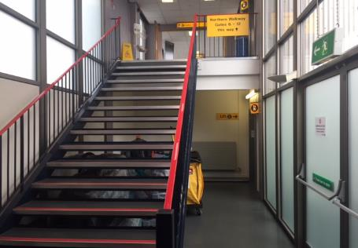
Lift

Northern Walkway corridor

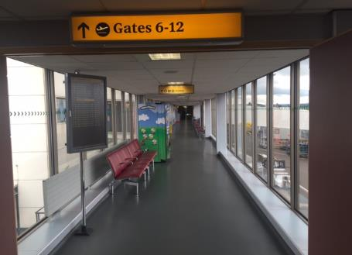

There is a large seating area at Gate 10 which generally has a lot less passengers than the main departure lounge so it is ideal if you are looking for a quieter area.

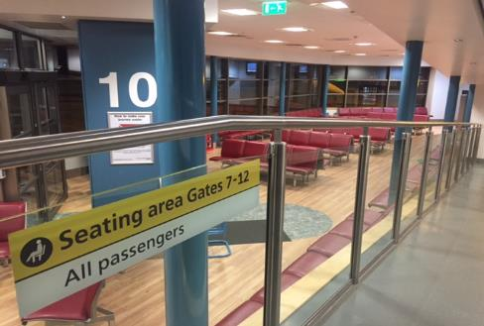
This area can be quieter than the main departure lounge

If you have any questions/concerns you can speak to the assistance contractor by using the help phone situated in the Gate 10 lounge.

If you would like to provide any feedback about the assistance service in general or specifically about this guide please contact us either via email abzfeedback@aiairport.com or by mobile phone by sending a free text to 80800, starting your message with the word ‘airport’.

